Unit 4 - 1Laboratory – Profiling

4.1 Objective:
This laboratory exercises guide you how to measure the program’s performance using profiling. On completion of this laboratory, you should be able to
- Understand how to measure the program’s running time
- Be aware the importance of tuning your program to be faster

4.2 Procedure 1 - Profile

4.2.1 Activity 1 – familiarization with Profiling
Type the following program that is a simple one dimensional matrix. It will initialize it with a value of 1.0; it then forms two loops to initialize it.
void main() {
int i,j;
float a[100];
for (i = 0; i <100; i++)
a[i] =1.0;
for(i=0;j<100;j++){
for (j=1;j<=100;i++){
a[i] = a[j];

}
}
}

Under the project, select setting and general, tick enable profiling as below.
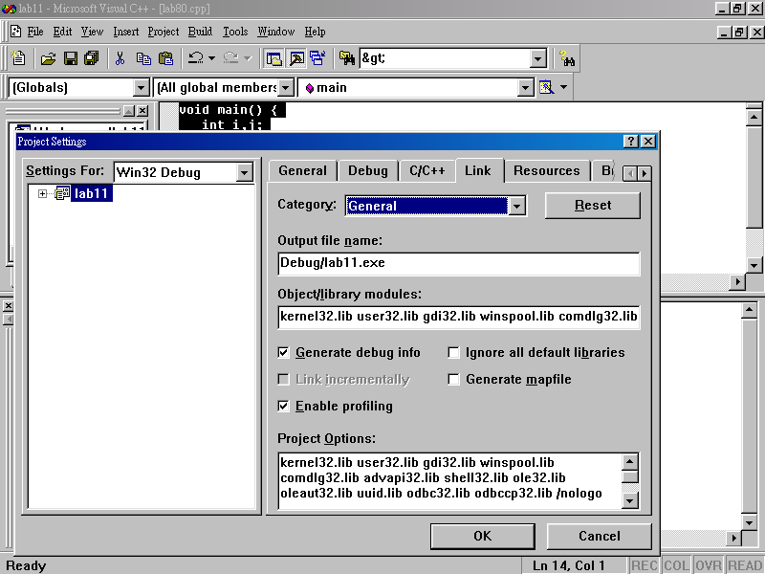

compile it and rebuild again, and click profile

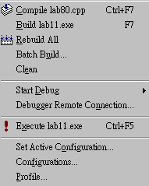

You will see that it displays the following data.

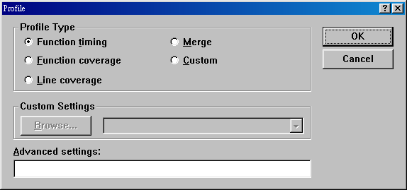

Select timing and press OK. It will display the following result.

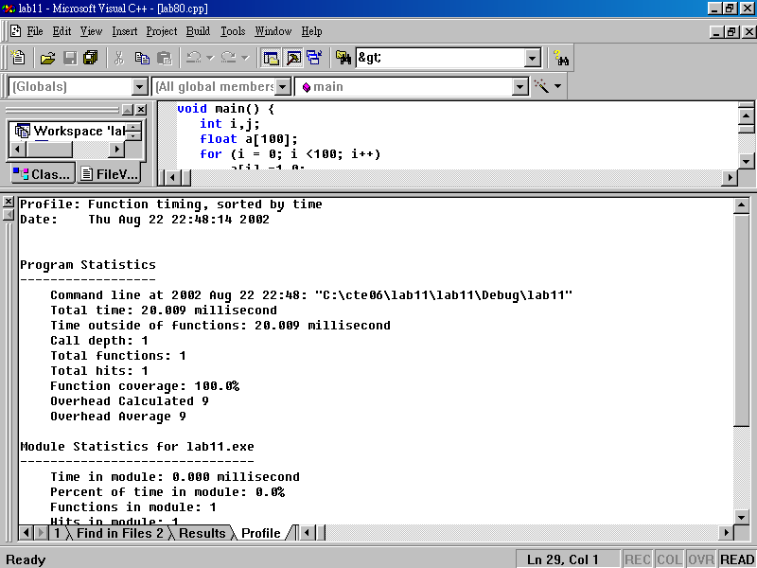
date

Now let us look at the figure.
Profile: Function timing, sorted by time
Date: Thu Aug 22 22:48:14 2002
Program Statistics
Command line at 2002 Aug 22 22:48: “C:\cte06\lab11\lab11\Debug\lab11”
Total time: 20.009 millisecond
Time outside of functions: 20.009 millisecond
Total time of the program
Call depth: 1
Total functions: 1
Total hits: 1
Function coverage: 100.0%
Overhead Calculated 9
Overhead Average 9

Module Statistics for lab11.exe
Time in module: 0.000 millisecond
There is no subroutine. That is why Func+Child = 0.000
Percent of time in module: 0.0%
Functions in module: 1
Hits in module: 1
Module function coverage: 100.0%

Func Func+Child Hit
Time % Time % Count Function
0.000 0.0 0.000 0.0 1 _main (lab80.obj)

Now select line coverage and understand the result.

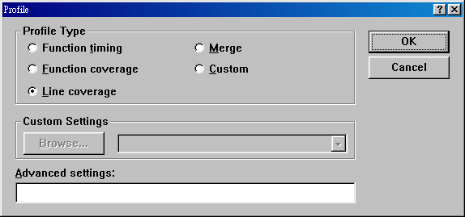

You will find that it displays the line for each statement as well.

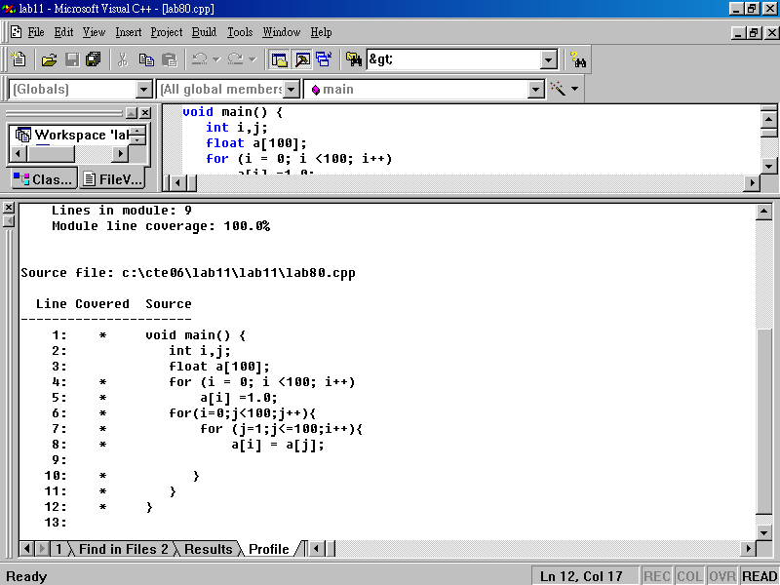

Now select Function coverage and explain why there is only one function.
因为只有一个main函数

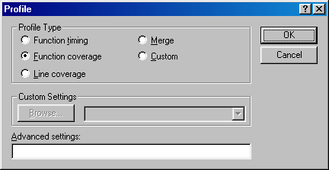

4.2.2 Activity 2 – add function
Now type the program, you can open my file and use cut and paste. Please note that a subroutine called assign is created. Forget about the meaning of this program, it is designed to make you familiarize with the profiling only.
float a[100];
void assign(int i) {
int j;
for (j = 0; j <100; j++)
a[i] = a[j];

}
void main() {
int i;
for (i = 0; i <100; i++)
a[i] =1.0;
for (i = 0; i < 100; i++)
assign(i);
}

Now enable profiling, compile and rebuild the above program, you will get the following screen.
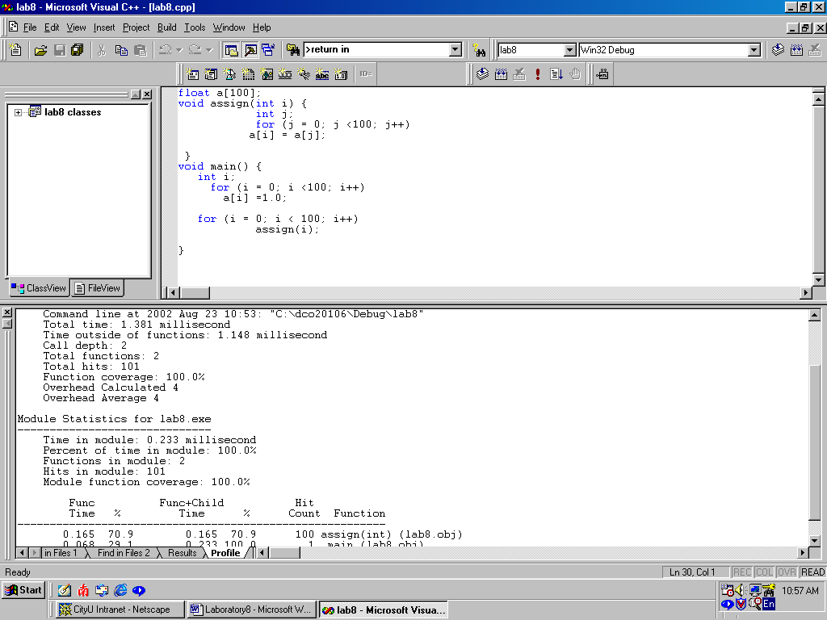

Now answer the following question so that you understand more about profiling. Complete the following from your system.
Func Func+Child Hit
Time % Time % Count Function

- Explain why the hit count of assign() is 100. (hint: look at the main())

函数assign被调用了100次

2) How many functions in this program and explain why?

2个函数，main与assign函数

3) Explain why the Hits in module: 101, not 1 or 2.

因为assign函数调用了100次，main函数调用了1次

- How many percentage of time the program spent in assign()?

86.6

- The Total time is: 1.381 millisecond in my machine (not the machine in the lab.). Please note that it varies form machine to machine. Explain the meaning of this 1.381 millisecond.

Total time = Time outside of functions + Time in module

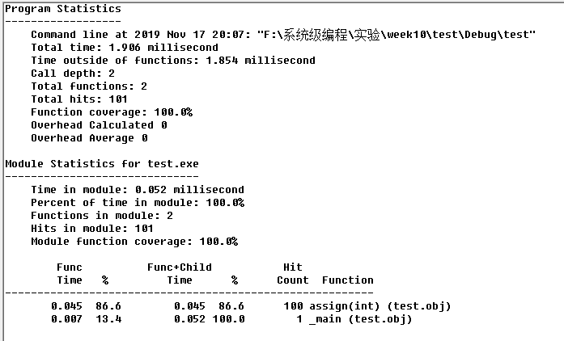

4.2.3 Activity 3 – understands how the program affects the performance
Measure the total time of the following program with the same result.
Case 1
#include <stdio.h>
#include <stdlib.h>
void main() {
int i;
int max_num = 1000;
for (i = 0; i < max_num; i++)
printf(“The power of %d is %d\n”, i, i*i);
}

The time is:______386.859ms________
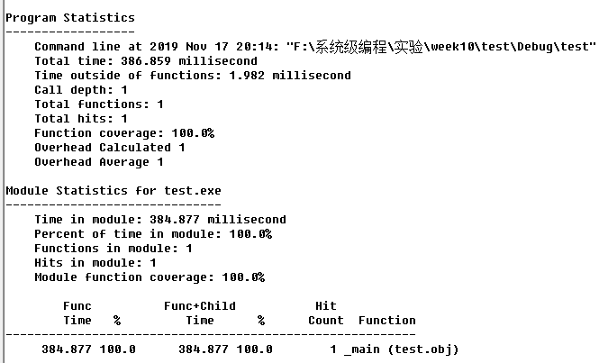

Case 2
#include <stdio.h>
#include <stdlib.h>
void main() {
unsigned int i;
unsigned int max_num = 1000;
for (i = 0; i < max_num; i++)
printf(“The power of %d is %d\n”, i, i*i);
}

The time is:______409.943ms________
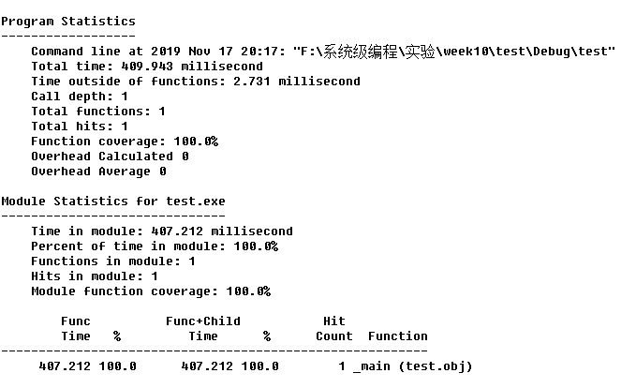

Case 3
#include <stdio.h>
#include <stdlib.h>
void main() {
int i = 0;
int max_num = 1000;
while (i < max_num){
printf(“The power of %d is %d\n”, i, i*i);
i = i + 1;
}
}

The time is:______442.594________
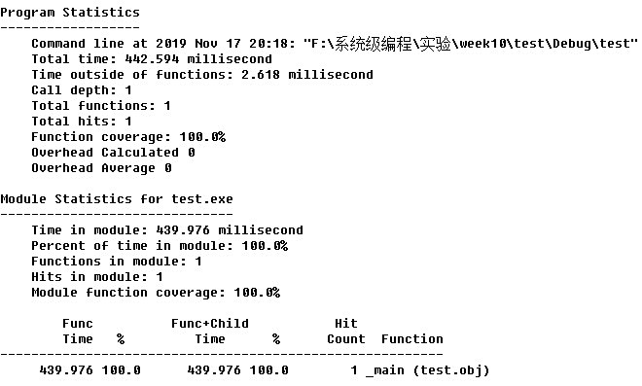

Case 4
#include <stdio.h>
#include <stdlib.h>
void main() {
int i = -1;
int max_num = 1000;
while (++i < max_num)
printf(“The power of %d is %d\n”, i, i*i);

}

The time is:_____400.663_________
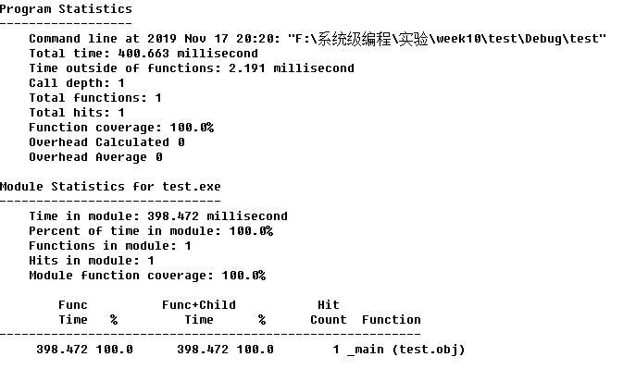

Case 5
#include <stdio.h>
#include <stdlib.h>
void prt(int i) {
printf(“The power of %d is %d\n”, i, i*i);
}
void main(){
int max_num = 1000;
for (int i = 0; i < max_num; i++)
prt(i);

}

The time is:_____412.213ms_________
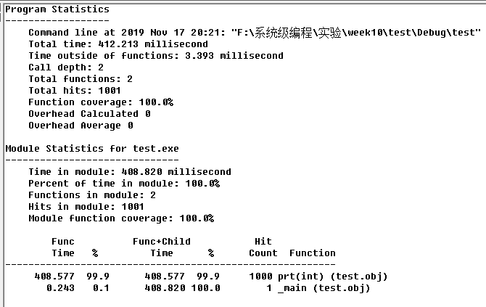

Case 6
#include <stdio.h>
#include <stdlib.h>
inline void prt(int i) {
printf(“The power of %d is %d\n”, i, i*i);
}
void main(){
int max_num = 1000;
for (int i = 0; i < max_num; i++)
prt(i);

}

The time is:_______402.616ms_______
